Design Document – Ronny14’s Pac-Man

Environment
Takes place in a dark maze.

Game Objects
- Pac-Man, player controlled
- Ghosts, move around trying to kill Pac-Man
- Dots, Pac-Man eats these to increase the score
- Orbs in the corners, lets Pac-Man eat ghosts
- Cherries, Pac-Man eats these to increase the score much more than the dots

Sounds
- Intro sound, plays when the game starts
- Ticking sound, plays when Pac-Man eats a dot
- Death sound, plays when Pac-Man gets killed by a ghost
- Juddering noise, plays when Pac-Man eats a ghost orb

Controls
- Players moves in the cardinal directions using the respective arrow keys.

Flow/Levels
- Pac-Man has to eat all the dots on a level to proceed to the next one.
- Each time Pac-Man is killed by a ghost, the player loses a life and if there are no lives left the game ends.
- Moving to new levels also increases the speed of the game.

Storyboard

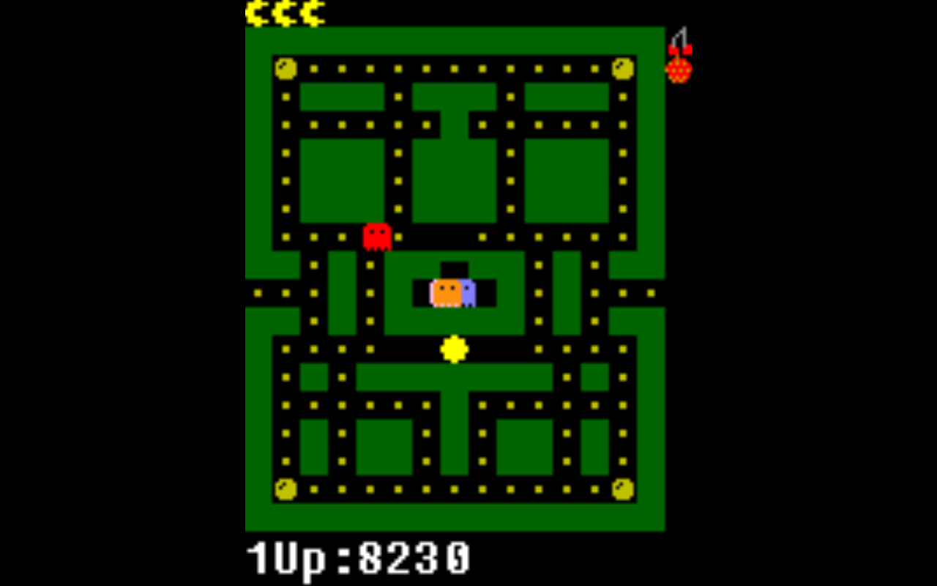

Player controls Pac-Man Player eats dots for points

If the player runs out of lives, the game ends

Ghost make the player lose a life if they come into contact with Pac-Man
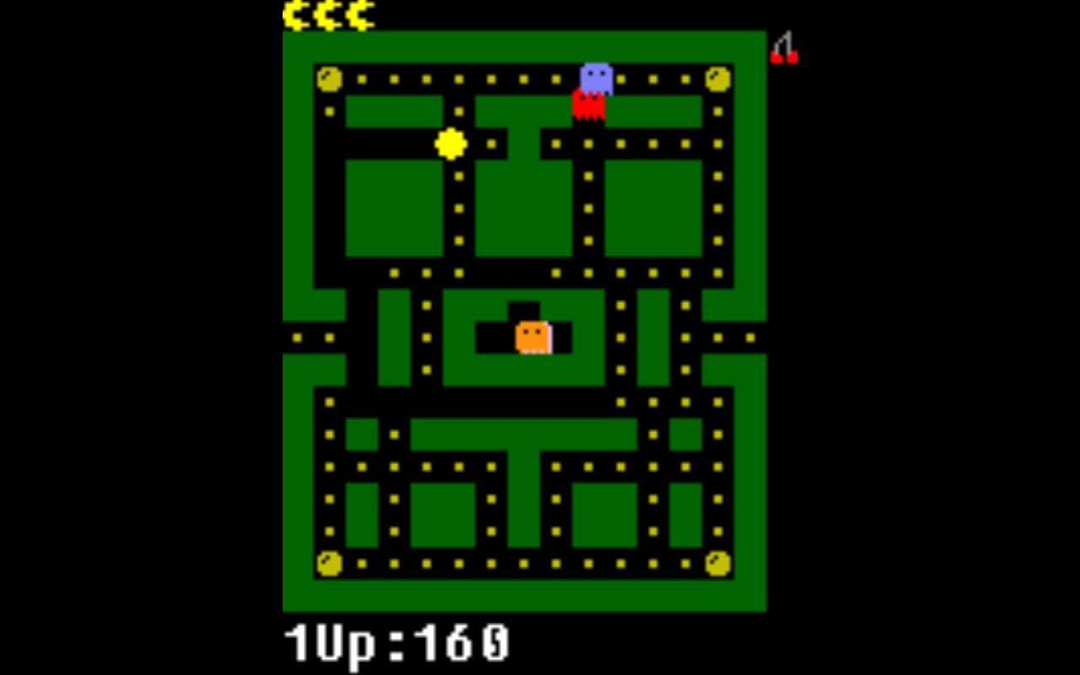

The player must eat all the dots to finish the level

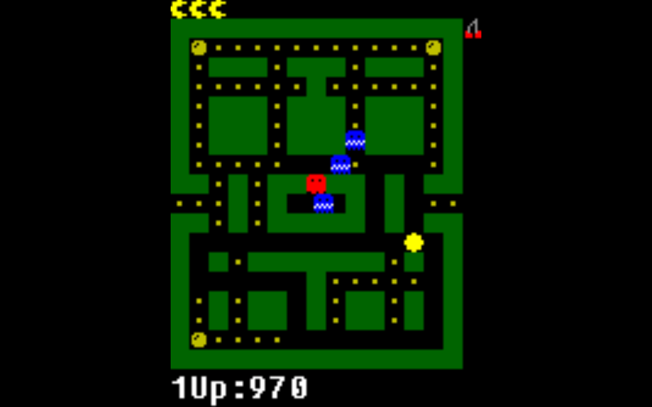

Pac-Man can eat the ghosts for a limited time after eating an orb

